In this project, you'll construct a half adder using an XOR gate and an AND gate. The inputs will be

controlled with switches or pushbuttons. The outputs should be connected to LEDs to easily observe

their states.

What is Half-Adder

Internally the half adder can be implemented as a combinational logic circuit, so we can also describe

with a truth table.

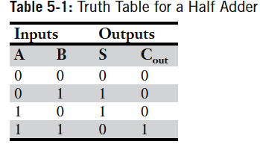

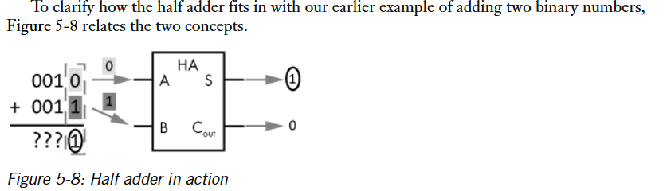

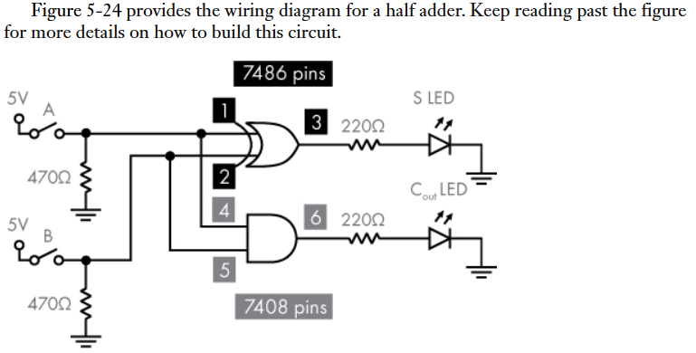

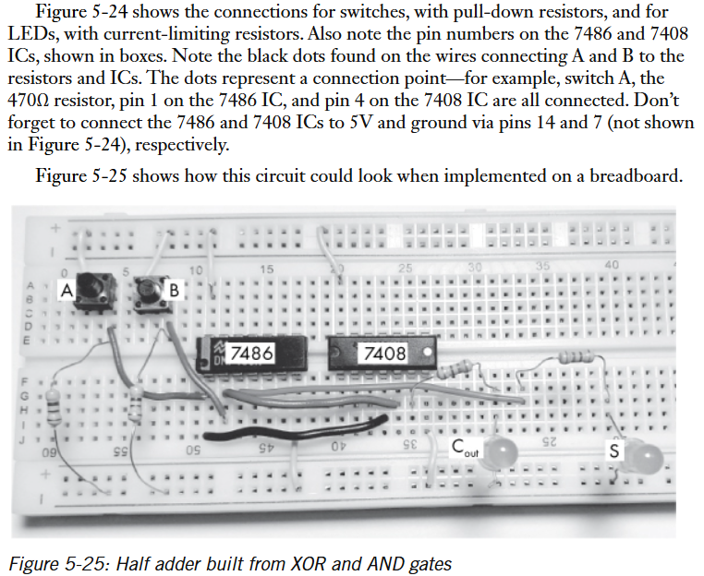

.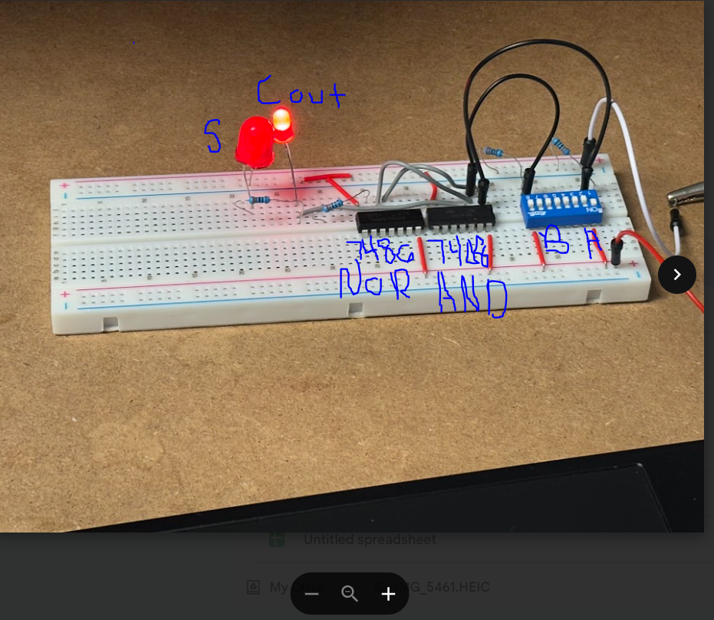

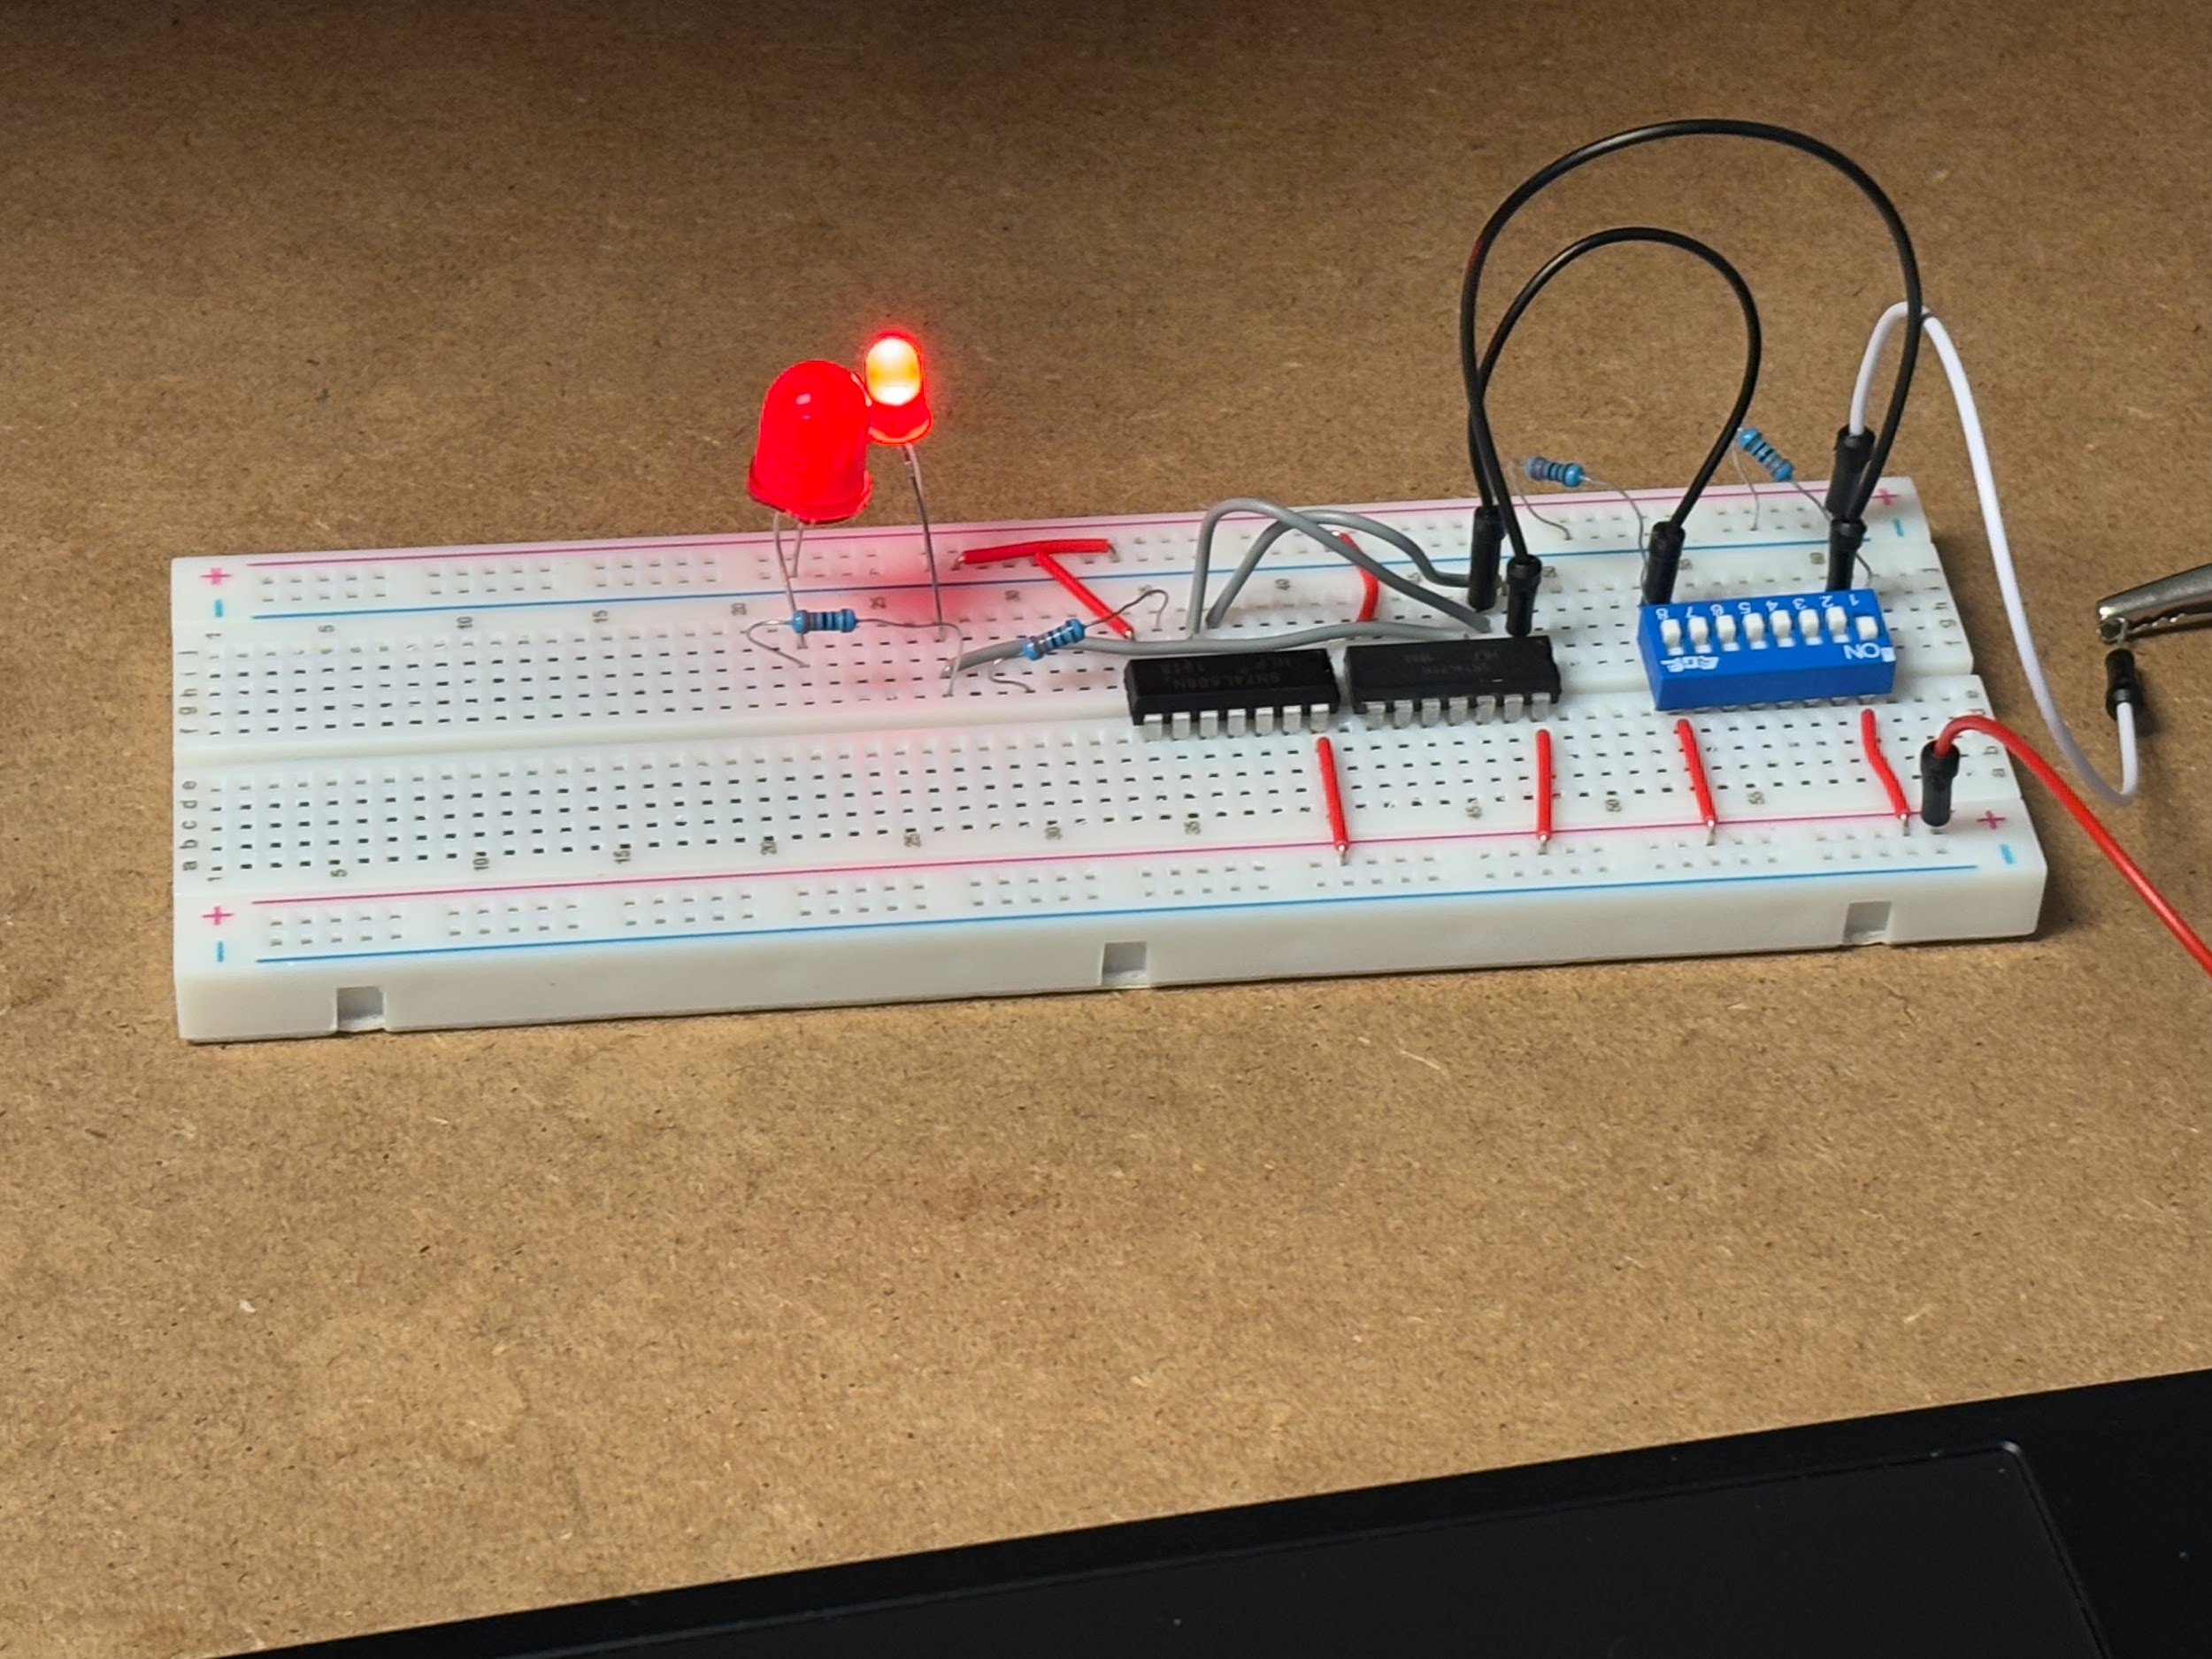

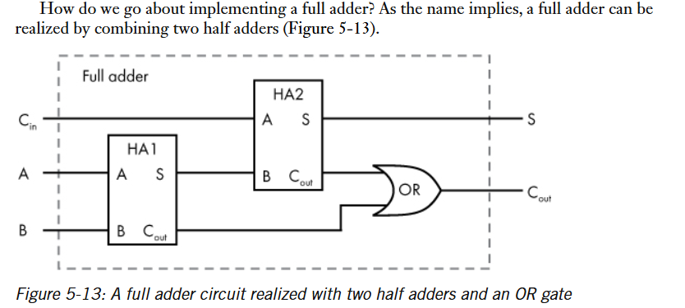

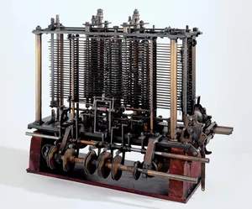Analytical Engine, generally considered the first [computer](https://www.britannica.com/technology/computer), designed and partly built by the English inventor [Charles Babbage](https://www.britannica.com/biography/Charles-Babbage) in the 19th century (he worked on it until his death in 1871). While working on the [Difference Engine](https://www.britannica.com/technology/Difference-Engine), a simpler calculating [machine](https://www.britannica.com/technology/machine) commissioned by the British government, Babbage began to imagine ways to improve it. Chiefly he thought about generalizing its operation so that it could perform other kinds of calculations. By the time funding ran out for his Difference Engine in 1833, he had conceived of something far more revolutionary: a general-purpose computing machine called the [Analytical](https://www.merriam-webster.com/dictionary/Analytical) Engine.

References

<https://www.britannica.com/technology/Analytical-Engine>